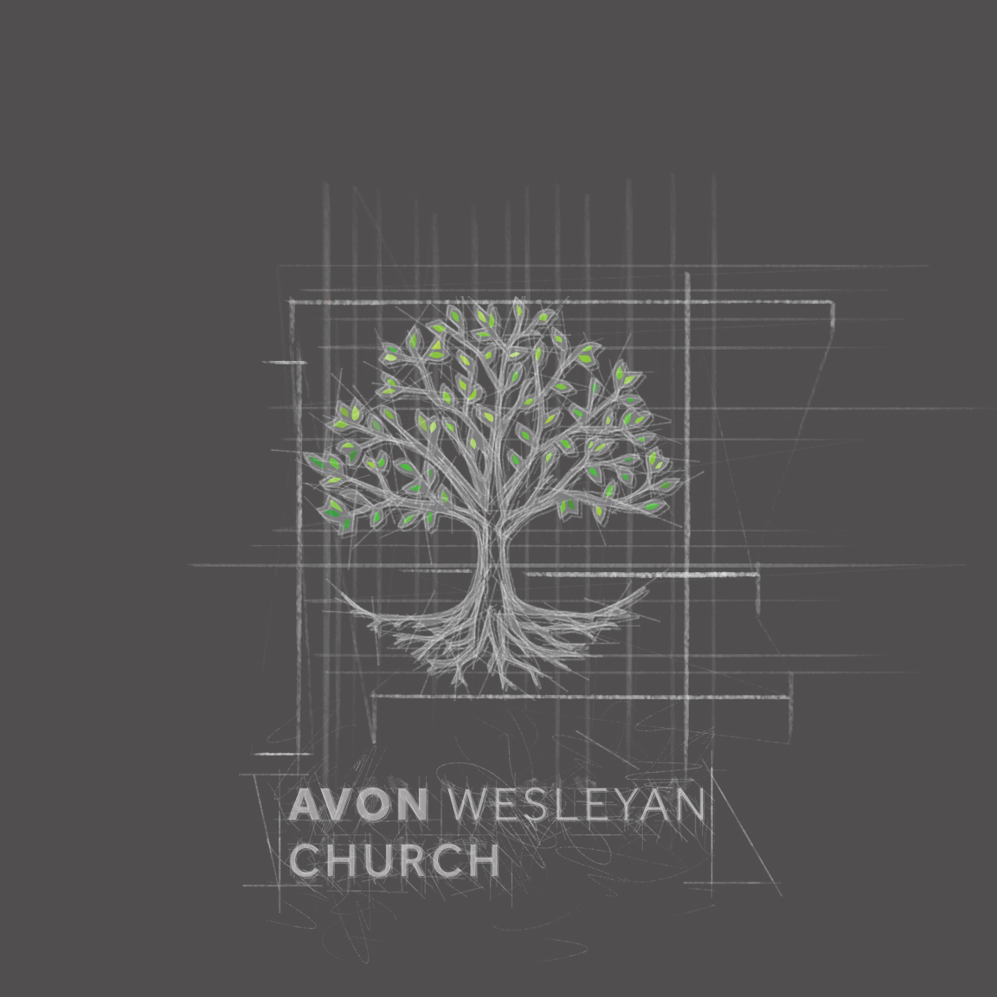

*Newsletters are unavailable at this time.*

*Please view Video Updates for Information and Events!*